# The Seminal Conspiracy Cases

American Tobacco Co. v. United States (1946).[1] On July 24, 1940, the Department of Justice filed a criminal information in the Eastern District of Kentucky against the “Big Three” American tobacco companies—the American Tobacco Company, Liggett & Myers Tobacco, and R.J. Reynolds Tobacco Company—five other corporations, and various subsidiaries and officers. The information charged in four counts a conspiracy to restrain trade, monopolization, attempted monopolization, and conspiracy to monopolize interstate trade in leaf tobacco and tobacco products in violation of Sections 1 and 2 of the Sherman Act.

In essence, on leaf tobacco the information charged that the defendants through their purchasing practices combined to set the prices for leaf tobacco and separately to control the quantities of leaf available to their competitors, thus limiting the ability of their competitors to grow and conferring on the defendants the power to exclude their competitors altogether. On tobacco products, mainly cigarettes, the information charged the defendants as sellers with simple price fixing, including price fixing on discounts to weaken their smaller competitors.

Before trial, the five smaller corporate defendants, along with their subsidiaries and officers, were severed from the case pursuant to a stipulation that they would plead nolo contendere if the Big Three were convicted at trial.

Trial began on June 2, 1941, and on October 27, 1941, the jury returned a verdict of guilty on each of the four counts against substantially all defendants that stood trial. The district court merged the conviction of attempted monopolization into the conviction of monopolization, and imposed fines totaling $255,000 on each of the three remaining counts against each of the convicted defendants.[2] On appeal, the Sixth Circuit affirmed the convictions.

The Supreme Court granted the defendants writs of certiorari limited to whether actual exclusion of competitors is a necessary element of monopolization. We will examine monopolization and the other Section 2 offenses in detail later. Suffice it to say for now that monopolization deals with the power to exclude competitors and corner a substantial portion of the market. Attempted monopolization involves efforts to obtain a monopoly that have a dangerous probability of success, while a conspiracy to monopolize is concerted action with the purpose of obtaining a monopoly. A “high” market share is a critical evidence in the proof of Section 2 offenses. In *American Tobacco*, none of the defendants individually had market shares that would either give them market power or any likelihood that they could achieve it, but collectively they satisfied the threshold at the time. Accordingly, the existence of a conspiracy between the defendants was critical for the Section 2 convictions in order to aggregate the shares.

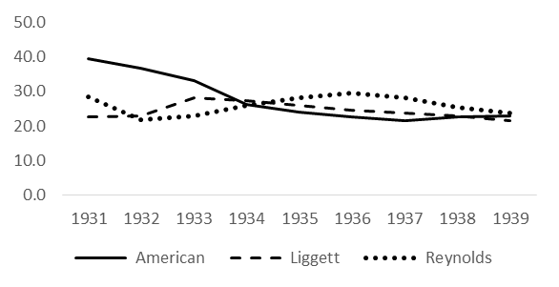”Big Three” Cigarette Market Shares[3]

|  |  |  |  |  |  |  |  |  |  |
| --- | --- | --- | --- | --- | --- | --- | --- | --- | --- |
|  | 1931 | 1932 | 1933 | 1934 | 1935 | 1936 | 1937 | 1938 | 1939 |
| American | 39.5 | 36.6 | 33.0 | 26.1 | 24.0 | 22.5 | 21.5 | 22.7 | 22.9 |
| Liggett | 22.7 | 23.0 | 28.1 | 27.4 | 26.0 | 24.6 | 23.6 | 22.9 | 21.6 |
| Reynolds | 28.4 | 21.8 | 22.8 | 26.0 | 28.1 | 29.5 | 28.1 | 25.3 | 23.6 |
| Combined | 90.7 | 81.4 | 83.9 | 79.5 | 78.0 | 76.7 | 73.3 | 71.0 | 68.0 |

The evidence of combination in *American Tobacco* was only circumstantial; there was no direct evidence through testimony or documents, for example, that the defendants had reached any agreement. In an often-quoted passage, the Court stated the rules for inferring conspiracy from circumstantial evidence:

It is not the form of the combination or the particular means used but the result to be achieved that the statute condemns. It is not of importance whether the means used to accomplish the unlawful objective are in themselves lawful or unlawful. Acts done to give effect to the conspiracy may be in themselves wholly innocent acts. Yet, if they are part of the sum of the acts which are relied upon to effectuate the conspiracy which the statute forbids, they come within its prohibition. No formal agreement is necessary to constitute an unlawful conspiracy. Often crimes are a matter of inference deduced from the acts of the person accused and done in pursuance of a criminal purpose. Where the conspiracy is proved, as here, from the evidence of the action taken in concert by the parties to it, it is all the more convincing proof of an intent to exercise the power of exclusion acquired through that conspiracy. The essential combination or conspiracy in violation of the Sherman Act may be found in a course of dealings or other circumstances as well as in any exchange of words. United States v. Schrader’s Son, 252 U.S. 85, 40 S. Ct. 251, 64 L. Ed. 471. Where the circumstances are such as to warrant a jury in finding that *the conspirators had a unity of purpose or a common design and understanding, or a meeting of minds in an unlawful arrangement, the conclusion that a conspiracy is established is justified.*[4]

A criminal conviction by a jury must be sustained unless as a matter of law the jury could not have found on the evidentiary record, with all reasonable inferences drawn in favor of the government, some element of the crime beyond a reasonable doubt. Under this standard, and the rules for inferring conspiracy evidence from circumstantial evidence, the Supreme Court sustained the Section 2 convictions.

Notes

1. Even in 1941, antitrust cases were expensive. Business Week at the time estimated the trial costs to be $1,000,000.[5]

Interstate Circuit, Inc. v. United States (1939).[6] *Interstate Circuit* is usually cited for the proposition that concerted action under the Sherman Act may be proved by circumstantial evidence as well as by direct evidence.

* *Direct evidence* is evidence probative of an element of the violation or a defense without the need to draw an inference. Direct evidence, for example, includes an email that memorialized the terms of an alleged price-fixing meeting, the oral testimony of a conspirator about what happened at the meetings the witness attended that were allegedly in furtherance of the price-fixing agreement, and a (lawful) wiretap of a telephone between two alleged conspirators about the problems of enforcing the cartel agreement. In each case, the evidence goes directly to the existence of the price-fixing conspiracy and the identities of the conspirators without the need for the trier of fact to draw any inference.
* *Circumstantial evidence* is evidence probative of an element of the violation or a defense but which requires the trier of fact to draw some inference from the evidence presented to the element of the case sought to be proved. Circumstantial evidence, for example, would include evidence of the occurrence but not the content of a meeting attended by the alleged conspirators, evidence of identical prices and price changes by the alleged conspirators, and evidence of parallel conduct by the alleged conspirators on activities that tend to increase the equilibrium price in the market.

Interstate Circuit and Texas Consolidated Theatres were two affiliated motion picture exhibitors operating 109 first- and subsequent-run theaters mostly in Texas. They had their principal place of business in the Majestic Theatre building in Dallas, Texas, and shared a common president, Karl Hoblitzelle, and a common general manager, R.J. O’Donnell.

Interstate and Texas Consolidated dominated the motion picture business in the geographic areas in which their theaters were located and contributed more than 74 percent of the total license fees paid by exhibitors in their respective territories. They were especially dominant in first-run theaters, which typically charged a nighttime adult admission charge of 40 cents or more. Hoblitzelle and O’Donnell had acquired their theaters from bankruptcy court, but, notwithstanding their dominance, the theaters had yet to become successful. Hoblitzelle and O’Donnell traced their difficulties to competition from subsequent-run theaters operated by third parties. Subsequent-run theaters typically charged a nighttime adult admission charge of 20 cents or less. Given the price differential and the fact that they often showed double features, subsequent-run theaters could draw customers away from first-run theaters.

On July 11, 1934, O’Donnell sent an identical letter to the branch managers of each of the eight major motion picture distribution companies. These eight companies—Paramount, Vitagraph, RKO, Columbia, United Artists, Universal Film Exchanges, Inc., Metro-Goldwyn-Mayer, and Twentieth Century Fox—collectively distributed 75 percent of the first class feature motion pictures produced in the United States. On July 11, 1934, O’Donnell’s letter made two demands as a condition of the continued distribution of a distributor’s films in Interstate’s first-run theaters in the 1934‑1935 season:

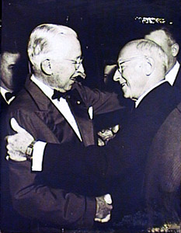

Karl Hoblitzelle and Cecil B. DeMille

For any film exhibited in an Interstate first-run theater, the distributor must agree to license that film to a subsequent-run theater only on the condition that the subsequent-run theater charge 25 cents or more as the adult evening admission price; and

For any film exhibited in an Interstate first-run theater, the distributor must agree to require other theaters not to exhibit the film as part of a double feature.[7]

These conditions, if implemented, would have significantly changed the way that motion pictures were generally exhibited by subsequent-run theaters and benefitted Interstate and Consolidated Theatres in two important ways: (1) they would reduce price and feature competition for their first-run theaters from third-party subsequent-run theaters, and (2) they would tend to increase prices in subsequent-run exhibition, both by raising the general price level for nighttime adult admission and by requiring two separate admission fees for what previously had been double features.

The branch managers for the major distributors each forwarded the O’Donnell demands to their respective superiors, and O’Donnell and Hoblitzelle met separately with officials from each distribution company. Ultimately, each distributor agreed to the O’Donnell demands in four of the six Texas cities served by Interstate.

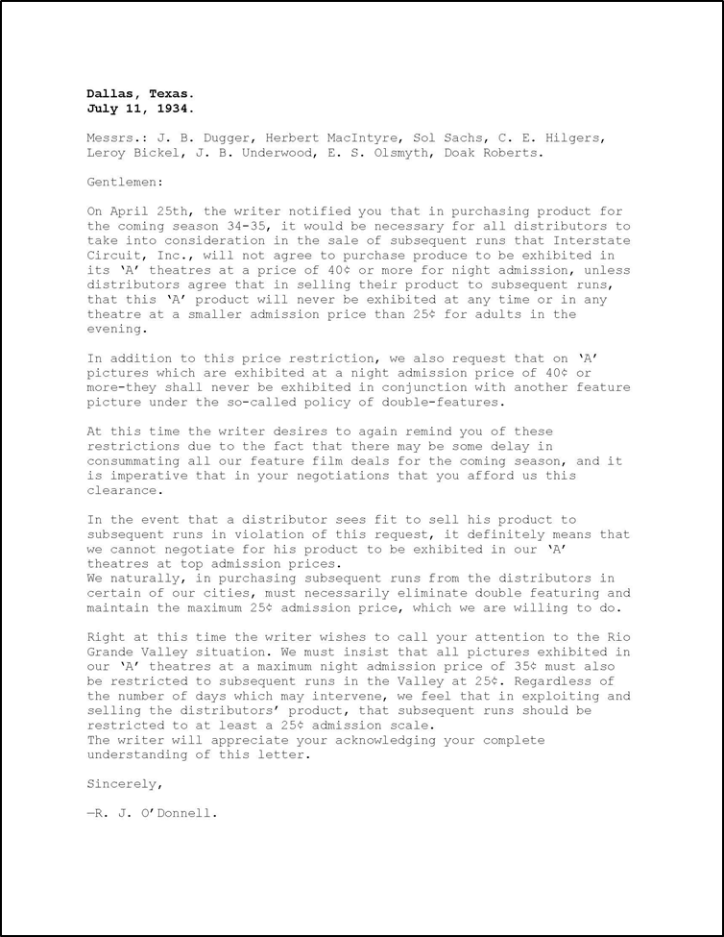On December 15, 1936, the Justice Department filed a petition in equity in the Northern District of Texas against Interstate Circuit, Texas Consolidated, Hoblitzelle, O’Donnell, and the eight distribution companies alleging that the defendants engaged in a conspiracy to set minimum admission prices in subsequent-run theaters and to prohibit the use of the films in question in double features in violation of the Sherman Act.

The district court held that all of the defendants, including the eight distributor defendants, engaged in a unified single conspiracy, even though no evidence was cited that the distributors communicated with one another in connection with Interstate’s demands. This has become known as a *hub and spokes conspiracy*. The idea is that the hub (here, Interstate) managed the conspiracy, each of the conspirators had common knowledge of the involvement of the other co‑conspirators, and each of the conspirators shared a common objective to achieve an unlawful end (here, an increase in second-run admission prices) through the conspiracy. In finding a single conspiracy, the district court relied in part on the following evidence:

* O’Donnell sent an identical letter containing the two demands to each of the eight distributors.
* Each of O’Donnell’s letters identified all eight distributors, so that each distributor knew that the other seven distributors had received the same demand.
* Each distributor’s agreements with third-party exhibitors in the four cities acceded to O’Donnell’s demand in identical language (using the language of O’Donnell’s letter).
* The distributors testified that they did not meet together because certain terms of their Interstate distribution agreements contained confidential terms (including the amount of rental and the number of films to be used), which differed to some degree among the various distribution agreements, yet other terms (relating to the O’Donnell demands) that should have been equally confidential and arguably could have equally varied among the distribution agreements were known and acceded to by all distributors with no variations.

Having found a conspiracy in violation of Section 1, the district court enjoined the conspiracy and restrained the distributors from enforcing the restrictions in their license agreements with third-party subsequent‑run exhibitors.

The defendants appealed directly to the Supreme Court under the Expediting Act. The Court, in a five-to-three decision, affirmed.[8] Justice Harlan F. Stone, writing for the majority, began by emphasizing the role of circumstantial evidence in proving antitrust conspiracy cases:

As is usual in cases of alleged unlawful agreements to restrain commerce, the government is without the aid of direct testimony that the distributors entered into any agreement with each other to impose the restrictions upon subsequent‑run exhibitors. In order to establish agreement it is compelled to rely on inferences drawn from the course of conduct of the alleged conspirators.[9]

Stone agreed that the district court did not err in drawing the inference of a single unified conspiracy from the evidence the district court cited. Stone then added that the distributors also had a strong incentive to conspire with one another in acceding to Interstate’s demands: each distributor knew that the same demand was being made on each of their major competitors, that in the absence of substantial unanimity there was a risk of substantial lost business and goodwill from the third-party subsequent‑run theaters by those who adopted the Interstate restrictions, and that with substantial unanimity there was the prospect of significantly increased profits. The Court concluded:

It taxes credulity to believe that the several distributors would, in the circumstances, have accepted and put into operation with substantial unanimity such far reaching changes in their business methods without some understanding that all were to join, and we reject as beyond the range of probability that it was the result of mere chance.[10]

Stone also thought that it was significant that the defendant-distributors, when confronted with the circumstantial evidence, did not attempt to contravene it through the testimony of their responsible employees:

This inference was supported and strengthened when the distributors, with like unanimity, failed to tender the testimony, at their command, of any officer or agent of a distributor who knew, or was in a position to know, whether in fact an agreement had been reached among them for concerted action. When the proof supported, as we think it did, the inference of such concert, theburden rested on appellants of going forward with the evidence to explain away or contradict it. They undertook to carry that burden by calling upon local managers of the distributors to testify that they had acted independently of the other distributors, and that they did not have conferences with or reach agreements with the other distributors or their representatives. The failure under the circumstances to call as witnesses those officers who did have authority to act for the distributors and who were in a position to know whether they had acted in pursuance of agreement is itself persuasive that their testimony, if given, would have been unfavorable to appellants. The production of weak evidence when strong is available can lead only to the conclusion that the strong would have been adverse. Silence then becomes evidence of the most convincing character.[11]

Justice Owen J. Roberts, joined by Justices James Clark McReynolds and Pierce Butler, dissented and would have reversed the decree. Roberts would have rejected the finding of a single hub and spokes conspiracy as unsupported by the properly admitted evidence. In the district court, the parties had entered into a stipulation of facts in lieu of evidence, although they agreed that any party might introduce additional evidence not inconsistent with the stipulation. The parties did introduce additional evidence, and the district court made ten subsidiary findings based upon this evidence. It was largely these subsidiary findings that provided the basis for the district court’s finding of a unified conspiracy. On appeal, the defendants attacked a number of these findings as contrary to the stipulation of facts or contrary to uncontradicted and unimpeached testimony. Roberts agreed that the evidence, considered in light of the procedure adopted in the district court, did not support the critical basic findings.

NoteS

1. A conspiracy among the distribution companies was important to a finding of illegality. Motion pictures were copyrighted, and at the time the copyright owner (the distribution company) was free to specify admission prices in the exhibition license agreement. It was somewhat less settled whether a copyright owner could agree with an exhibitor as to the admission prices that the copyright owner would specify in its license agreements with third-party exhibitors. It was well-settled, however, that competing copyright owners could not agree among themselves as to the admission prices that they would specify in their respective license agreements with third-party exhibitors.

Interstate/  
Texas Consolidated



Distribution  
companies

Unified single   
“hub and spokes” conspiracy   
(unlawful)

Eight separate single agreements   
(unsettled)

Single agreement   
(lawful)

Possible Conspiracy Configurations in *Interstate Circuit*

2. *Interstate Circuit* involved two other important questions in addition to the issue of whether there was a single over-arching conspiracy: (a) taken as individual agreements, were the restrictions each distributor individually agreed with Interstate to impose on third-party subsequent-run theaters within the scope of the rights provided to the distributor as the copyright holder under the copyright laws, and (b) were the restraints unreasonable within the meaning of the Sherman Act? The district court held, and the Supreme Court agreed, that the restrictions, even if considered individually, were not protected by the copyright law and that they were unreasonable restraints within the meaning of the Sherman Act. On both questions, the courts were influenced by the adverse effect of the restrictions on third parties. The restrictions forced the third-party exhibitors to significantly raise their admission prices and to decrease the benefit delivered to their customers by eliminating double features. The result was a loss of customers and profits to first-run theaters (mostly to Interstate theaters). Theaters in poor areas were especially hard hit, since they often depended on the ability to offer double features at a low price to attract customers, and many of these theaters went out of business. While the courts were willing to allow a copyright holder unilaterally to set conditions on admission prices and double features on which it would grant exhibition licenses, they were not willing to recognize this right when the conditions were imposed by agreement with a (financially interested) third party to the copyright. Not only could such agreements distort the incentives of the copyright holder, they also could—as they did in *Interstate Circuit*—force a harmful artificial uniformity in the treatment of third parties and deprive the copyright holder of the ability to deal with licensees individually in light of the particular market conditions in which they operated.

3. The good character of the defendants and advice of counsel cannot save an otherwise unlawful arrangement. The district court noted that Mr. Hoblitzelle was one of Dallas’ “finest characters” and that he sought legal advice before Interstate began to pursue its demands.[12] The district court then observed:

The conclusion that this court reaches in this case, ultimately, is not a criticism of him nor a condemnation of him. Good motives, good intentions, are not a defense to actions brought for violations of this statute. Nor is one’s desire to have his own business prosperous a defense. Nor is the desire to see those who join in the formation of the plan, prosperous, a satisfactory answer to the negations of the law.[13]

It is effects and not motives that determine the legality of conduct under the antitrust laws.

Theatre Enterprises, Inc. v. Paramount Film Distributing Corp. (1954).[14] In the 1930s and 1940s, the core of a city was its downtown area. This is where the major businesses, the largest retail stores, and the most significant entertainment centers were located. People lived in the suburbs, but for the most part they worked, shopped, and played downtown. But this was changing. As the suburbs became more populated, shopping and entertainment venues followed.

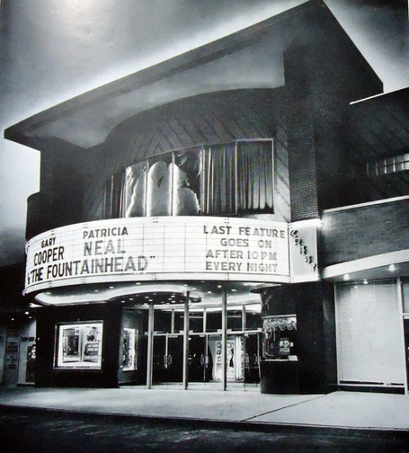On February 26, 1949, Theatre Enterprises opened the Crest Theatre, a modern, 1600-seat motion picture theater in a shopping center about six miles northwest from downtown Baltimore in a suburb of about 105,000 people. The Crest, which cost $460,000 to build (about $4.6 million in 2014 dollars), was designed with 1600 seats and the most modern equipment with the idea that it would play first-run films. Before construction began on the theatre, Theatre Enterprises approached each of the eight major motion picture distributors separately for exclusive first‑run privileges for the Crest, although it later asked for first-runs only on a “day and date” basis.[15] Each of the distributors replied it would not consider the application until the theatre was near completion. Several months before construction was to be finished, Theatre Enterprises renewed its applications. The branch managers of each distributor expressed surprise that Theatre Enterprises would seek to show first-run films outside of the downtown area, since it was the general practice in the industry to limit first runs to eight downtown theaters. During the discussions, Theatre Enterprises offered substantial guarantees of film rental and a percentage of the gross receipts. No distributor accepted these offers, and Theatre Enterprises continued to seek first-run privileges after the Crest opened. Ultimately, these efforts were unsuccessful, and Theatre Enterprises never obtained first-run privileges for the Crest from any major distributor and the Crest was relegated to playing second-run pictures.

The Crest Theatre

On March 20, 1950, Theatre Enterprises brought an antitrust suit against the eight major motion picture distributors. Theatre Enterprises alleged that the defendants had violated Sections 1 and 2 of the Sherman Act by conspiring between February 1949 and March 1950 to restrict first‑run pictures to downtown Baltimore theatres, and, in furtherance of this conspiracy, confining the Crest to subsequent runs, charging it discriminatorily high license rates, and imposing unreasonable “clearances” on it. Theatre Enterprises claimed injury to its business and property as a result of the alleged violation and sought treble damages and injunctive relief.[16]

The defendants argued that the complaint should be rejected for lack of conspiracy. There was no evidence of an explicit agreement among the defendants nor was any conspiracy charged involving the studios and the independent theaters, which accounted for 63 percent of first-run exhibitions. Each of the studios testified that, in dealing with the Crest, it made its decisions unilaterally for good, self-interested business reasons. These reasons were substantially the same across the studios. A “day and date” license for first-run films would be uneconomical, since the Crest was in “substantial competition” with the downtown theaters for patronage and to maximize the box office take first-run films were only licensed to theaters that did not compete with one another. Nor did an exclusive license make sense, since, given its location and the limited transportation facilities that served it, the Crest could draw from a population only one-tenth the size of a downtown theater. The defendants also testified that, given the Crest’s limited draw area, they did not believe that Theatre Enterprises’ offers of guarantees of film rental and a percentage of the gross receipts were realistic or made in good faith. Loew’s and Warner refused to give the Crest an exclusive license since they owned the downtown theaters that received their first-run licenses.

Theatre Enterprises argued that the conscious unanimity of how to deal with the Crest was sufficient to compel the finding that there was concerted action within the meaning of the Sherman Act and that the district court should direct a verdict in its favor as a matter of law. The only question for the jury was the amount of damages.

The district court submitted the case to the jury, which returned a general verdict for the defendants. The Fourth Circuit affirmed, finding that the evidence could support a finding of liability for either side and hence the question of liability was properly one for the jury.

The Supreme Court, in a seven-to-one decision, also affirmed the jury verdict for the defendants. Justice Tom C. Clark, who wrote the opinion for the majority, set out the question for the Court:

The crucial question is whether respondents’ conduct toward petitioner stemmed from independent decision or from an agreement, tacit or express. To be sure, business behavior is admissible circumstantial evidence from which the fact finder may infer agreement. But this Court has never held that proof of parallel business behavior conclusively establishes agreement or, phrased differently, that such behavior itself constitutes a Sherman Act offense. Circumstantial evidence of consciously parallel behavior may have made heavy inroads into the traditional judicial attitude toward conspiracy; but “conscious parallelism” has not yet read conspiracy out of the Sherman Act entirely.[17]

Recall that in *Interstate Circuit* the Court allowed that evidence of conscious parallelism could be probative of conspiracy when there was no good business reason for all of the defendants to come to the same decision unilaterally. Theatre Enterprises presented the case where there was a good business reason for the various defendants to engage in the same conduct acting unilaterally:

Here each of the respondents had denied the existence of any collaboration and in addition had introduced evidence of the local conditions surrounding the Crest operation which, they contended, precluded it from being a successful first run house. They also attacked the good faith of the guaranteed offers of the petitioner for first run pictures and attributed uniform action to individual business judgment motivated by the desire for maximum revenue. This evidence, together with other testimony of an explanatory nature, raised fact issues requiring the trial judge to submit the issue of conspiracy to the jury.[18]

Having decided that the evidence in the case presented a jury question on whether the defendants conspired, and the jury having returned a verdict for the defendants, the Supreme Court affirmed.

Notes

1. Theatre Enterprises also argued that the district court erred in failing to give proper weight to the recent *Paramount* decrees. Section 5(a) of the Clayton Act provides in pertinent part:

A final judgment or decree heretofore or hereafter rendered in any civil or criminal proceeding brought by or on behalf of the United States under the antitrust laws to the effect that a defendant has violated said laws shall be prima facie evidence against such defendant in any action or proceeding brought by any other party against such defendant under said laws as to all matters respecting which said judgment or decree would be an estoppel as between the parties thereto: Provided, That this section shall not apply to consent judgments or decrees entered before any testimony has been taken.[19]

In 1944, the Department of Justice filed a petition to amend a 1940 consent decree against Twentieth Century-Fox Film Corporation, Loew’s, Inc., Paramount Pictures, Inc., RKO Radio Pictures, Inc., and Warner Bros. Pictures to prohibit “block booking,”[20] unreasonable clearances, and studio ownership of motion picture theaters.[21] After settlement negotiations failed, the government brought suit.[22] The trial court found the defendants had restrained and monopolized interstate trade in the distribution and exhibition of films by various challenged practices and ordered injunctive relief. Both the government and the defendants appealed to the Supreme Court, which affirmed in part, reversed in part, and remanded.[23] Over time, the defendants entered into consent decrees with the government in the course of the remand.[24]

Theatre Enterprises sought to use the *Paramount* judgments as prima facie evidence under Section 5 of the Clayton Act to establish the liability of the *Theatre Enterprises* defendants. The district court judge was not persuaded. The *Paramount* case had no relation to the Crest Theatre: the case did not involve a particular conspiracy concerning restrictions on runs and clearances in Baltimore theaters. Moreover, whatever the bounds of the *Paramount* conspiracy, it likely ended no later than the district court’s finding of liability in 1948, which was before the alleged conspiracy period in *Theatre Enterprises*. The district court judge, however, allowed the *Paramount* decrees to be admitted into evidence and considered by the jury, although he instructed the jury in effect that the Paramount decrees by themselves were insufficient as a matter of law to establish liability and that additional evidence specific to the plaintiff’s claims was required to establish liability. The Supreme Court agreed.

United States v. Container Corp. of America (1969).**[25]** On October 14, 1963, Department of Justice filed a civil complaint charging eighteen manufacturers of corrugated containers, with conspiring from January 1, 1955, to October 14, 1963, to restrict price competition in the Southeastern United States in violation of Section 1 of the Sherman Act. The complaint alleged that the defendants, which collectively accounted for roughly 90 percent of shipments in the Southeastern United States, agreed “to exchange among themselves information respecting prices that they have charged, contracted to charge, or quoted, specific customers” and that the effect of the conspiracy was in fact to reduce price competition. After trial, the district court dismissed the complaint and the Department of Justice appealed under the Expediting Act directly to the Supreme Court.

In a six-to-three decision, the Supreme Court reversed. Justice William O. Douglas wrote the short majority opinion. First, Douglas characterized the challenged conduct:

Here all that was present was a request by each defendant of its competitor for information as to the most recent price charged or quoted, whenever it needed such information and whenever it was not available from another source. Each defendant on receiving that request usually furnished the data with the expectation that it would be furnished reciprocal information when it wanted it. That concerted action is of course sufficient to establish the combination or conspiracy, the initial ingredient of a violation of § 1 of the Sherman Act.[26]

This was not a traditional price-fixing agreement, because there was no agreement to adhere to any price schedule and the defendants were free to charge any price they wished. All they had to do was disclose the price when asked. Yet Douglas found that there was an agreement among the defendants to exchange this price information, and this agreement satisfied the concerted action element of a prima facie Section 1 case. The question remained whether the agreement resulted in an unreasonable restraint of trade. Douglas found that it did:

The result of this reciprocal exchange of prices was to stabilize prices though at a downward level. Knowledge of a competitor’s price usually meant matching that price. The continuation of some price competition is not fatal to the Government’s case. The limitation or reduction of price competition brings the case within the ban, for as we held in *United States v. Socony-Vacuum Oil Co.*, [310 U.S. 150, 224, n.59, (1940),] interference with the setting of price by free market forces is unlawful per se. Price information exchanged in some markets may have no effect on a truly competitive price. But the corrugated container industry is dominated by relatively few sellers. The product is fungible and the competition for sales is price. The demand is inelastic, as buyers place orders only for immediate, short-run needs. The exchange of price data tends toward price uniformity. For a lower price does not mean a larger share of the available business but a sharing of the existing business at a lower return. Stabilizing prices as well as raising them is within the ban of s 1 of the Sherman Act. As we said in *United States v. Socony-Vacuum Oil Co.*, “in terms of market operations stabilization is but one form of manipulation.” The inferences are irresistible that the exchange of price information has had an anticompetitive effect in the industry, chilling the vigor of price competition. The agreement in the present case, though somewhat casual, is analogous to those in *American Column & Lumber Co. v. United States*, [257 U.S. 377 (1921),] and *United States v. American Linseed Oil Co.*, [262 U.S. 371 (1923)].[27]

Douglas concluded that “[p]rice is too critical, too sensitive a control to allow it to be used even in an informal manner to restrain competition” and reversed.[28]

Justice Abe Fortas wrote a concurring opinion to stress his view that exchanges of information among competitors, even price information, was not by themselves, per se unlawful. In this case, however, Fortas found that the evidence in the record showed that the *effect* of the information exchange was to stabilize prices at levels that were higher than they would have been in the absence of the information exchange. The district court had found that once a defendant learned of its competitor’s prices, it typically quoted substantially the same price as the competitor. Fortas noted that “[t]he obvious effect was to ‘stabilize’ prices by joint arrangement—at least to limit any price cuts to the minimum necessary to meet competition” and that in addition “there was evidence that, in some instances, during periods when various defendants ceased exchanging prices exceptionally sharp and vigorous price reductions resulted.”[29] Since the evidence showed that the effect of the agreement was in fact to stabilize prices at levels higher than what they would have been in the absence of the agreement, the *Container* arrangement was unlawful under the rule of reason.

Justice Thurgood Marshall, joined by Justices John M. Harlan and Potter Stewart, dissented. Marshall agreed with the majority that an agreement within the meaning of the Sherman Act existed to exchange information, but like Fortas he stressed that price information exchanges should not be subject to per se condemnation. But unlike Fortas, Marshall was not convinced that the *Container* arrangement had a competitively adverse on prices:

Nor do I believe that the Government has proved that the exchange of price information has in this case had the necessary effect of restraining price competition. In its brief before this Court, the Government relies very largely on one finding of the District Court and upon economic theory. The Government has presented a convincing argument in theoretical terms. However, the evidence simply does not square with that theory. And, this is not a case in which it would be unduly difficult to demonstrate anticompetitive effects.

The record indicates that defendants have offered voluminous evidence concerning price trends and competitive behavior in the corrugated container market. Their exhibits indicate a downward trend in prices, with substantial price variations among defendants and among their different plants. There was also a great deal of shifting of accounts. The District Court specifically found that the corrugated container market was highly competitive and that each defendant engaged in active price competition. The Government would have us ignore this evidence and these findings, and assume that because we are dealing with an industry with overcapacity and yet continued entry, the new entrants must have been attracted by high profits. The Government then argues that high profits can only result from stabilization of prices at an unduly high level. Yet, the Government did not introduce any evidence about the level of profits in this industry, and no evidence about price levels. Not one customer was called, although the Government surely had ample access to defendants' customers. The Government admits that the price trend was down, but asks the Court to assume that the trend would have been accelerated with less informed, and hence more vigorous, price competition. In the absence of any proof whatsoeverI cannot make such an assumption. It is just as likely that price competition was furthered by the exchange as is it that it was depressed.[30]

In the absence of sufficient evidence to find on the record an adverse effect on market prices, Marshall would have affirmed the dismissal of the case by the district court.

Notes

1. Despite the evidence of an actual competitively adverse effect on prices from the *Container* arrangement, Douglas’ innovation of *Socony-Vacuum* for the proposition that any “interference with the setting of price by free market forces is per se unlawful” suggested to many, including apparently Fortas and the dissenters, that the *Container* information exchange was per se unlawful.[31] The modern approach does not go so far doctrinally. Today, *Container* is thought to stand for two propositions:

a. An information exchange agreement coupled with evidence that the implementation of the agreement had a material and competitively adverse effect on market prices makes the information exchange agreement unlawful under the rule of reason.

b. An information exchange agreement coupled with evidence that the purpose and effect of the agreement was to stabilize prices is circumstantial evidence sufficient to support a finding of a per se unlawful price-fixing agreement.

1. . 328 U.S. 781 (1946), *aff’g* 147 F.2d 93 (6th Cir. 1944).
2. . The maximum criminal fine at the time was $5000. The court assessed the maximum fine against each convicted defendant on each of the three counts. American, one subsidiary and four officers were fined $90,000; Liggett and four officers were fined $75,000; and Reynolds and five officers were fined $90,000.
3. . For the data, see *American Tobacco*, 328 U.S. at 794.
4. . *Id*. at 809-10 (emphasis added).
5. . *Behind the Cigarette Verdict*, Business Week, Nov. 8, 1941, at 17, 18.
6. . 306 U.S. 208 (1939). The facts are drawn from the Supreme Court and district court decisions. The district court decision is reported at United States v. Interstate Circuit, Inc., 20 F. Supp. 868 (N.D. Tex. 1937).
7. . The text of the letter is reprinted at *Interstate Circuit*, 306 U.S. at 216 n.3.
8. . Justice Felix Frankfurter took no part in the decision. Frankfurter, who was nominated by President Franklin D. Roosevelt, was sworn in on January 30, 1939. *Interstate Circuit* was argued on January 11, 1939, before Frankfurter was sworn in, and there may have been a vote on the case prior to Frankfurter becoming a member of the Court. In any event, it is likely that Frankfurter arrived on the Court too late to participate in the decision.
9. . *Interstate Circuit*, 306 U.S. at 221.
10. . *Id*. at 223.
11. . *Id*. at 225-26 (citations omitted).
12. . *See Interstate Circuit*, 20 F. Supp. at 875.
13. . *Id*.
14. . 346 U.S. 537 (1954), *aff’g* 201 F.306 (4th Cir. 1953). The evidence is recounted in some detail in the Fourth Circuit’s opinion.
15. . These are the same eight major distributors that were the distributor-defendants in *Interstate Circuit*, although Theatre Enterprises alleged that they had now grown to control 95 percent of the first class feature motion pictures produced in the United States. Exclusive first-run privileges would mean that only the Crest would be licensed to show the picture in the Baltimore area. A “day and date” license would allow at least one other theater in the Baltimore area to simultaneously exhibit the film.
16. . A clearance is a right of exclusivity provided by the distributor to a first-run exhibitor in connection with the licensing of a first-run picture to be shown at a particular theater. The clearance provides that the distributor will not license the picture to another theater within a defined area (supposedly containing all and only theaters competitive with the licensed theater) before a specified period of time—at the time, usually 21 days—had elapsed after the licensed theater ceased exhibiting the picture.
17. . *Theatre Enters.*, 346 U.S. at 540-41 (citations and footnote omitted).
18. . *Id*. at 541 (internal citations omitted).
19. . 15 U.S.C. § 16(a). This provision was included as Section 5 in the original Clayton Act. Clayton Act, ch. 222, § 5, 38 Stat. 730, 731 (1914). The section was renumbered as Section 5(a) in 1955. Act of July 7, 1955, Pub. L. No. 84-137, 69 Stat. 282, 283 (1955).
20. Block booking is the practice of licensing films for exhibition only in groups and not individually. It is a form of tying arrangement, which we will address in Unit 21. At the time, the antitrust laws treated tying arrangements harshly, and the government maintained that the tying of copyrighted materials (here, the motion pictures) was a per se violation of the Sherman Act. Today, most block booking would not qualify as an illegal tying arrangement, although the practice continues to be regulated by consent decree.
21. . *See* U.S. Dept. of Justice, Press Release (Aug. 7, 1944). The original 1940 consent decree is reported at United States v. Paramount Pictures, Inc., 1940-43 Trade Cas. (CCH) ¶ 56,072 (S.D.N.Y. Nov. 20, 1940).
22. The United States reserved the right, after a three-year trial period, to seek the relief prayed for in the amended complaint. After the end of the three-year period, settlement negotiations for a new consent decree failed. Since the defendants in the 1940 consent decree had not admitted any violation of law and no issue of fact or law was adjudicated, a trial was necessary to find liability and fashion relief. *See* United States v. Paramount Pictures, Inc., 334 U.S. 131, 141 n.3 (1948).
23. . United States v. Paramount Pictures, Inc., 66 F. Supp. 323 (S.D.N.Y. 1946), *opinion issued*, 70 F. Supp. 53 (S.D.N.Y. 1946), *aff’d in part, rev’d in part and remanded*, 334 U.S. 131 (1948), *on remand*, 85 F. Supp. 881 (S.D.N.Y. 1949).
24. . *See* United States v. Paramount Pictures, Inc., 1948-49 Trade Cas. (CCH) ¶ 62,335 (S.D.N.Y. Nov. 8, 1948) (RKO); United States v. Paramount Pictures, Inc., 1948-49 Trade Cas. (CCH) ¶ 62,377 (S.D.N.Y. Mar. 3, 1949) (Paramount); United States v. Loew’s Inc., 1950-51 Trade Cas. (CCH) ¶ 62,573 (S.D.N.Y. Feb. 8, 1950) (Columbia, Universal and UA); United States v. Loew’s Inc., 1950-51 Trade Cas. (CCH) ¶ 62,861 (S.D.N.Y June 7, 1952) (Fox); United States v. Loew’s Inc., 1950-51 Trade Cas. (CCH) ¶ 62,765 (S.D.N.Y. Jan. 4, 1951) (Warner); United States v. Loew’s Inc., 1952 Trade Cas. (CCH) ¶ 67,228 (S.D.N.Y. Feb. 7, 1952) (Loew’s). *See generally* Brian J. Wolf, *The Prohibitions against Studio Ownership of Theatres: Are they an Anachronism?,* 13 Loy. L.A. Ent. L. Rev. 413 (1993).
25. . 393 U.S. 333 (1969), *rev’g* 273 F. Supp. 18 (M.D.N.C. 1967).
26. . *Id*. at 335.
27. . *Id*. at 336-37 (internal citations and footnotes omitted).
28. . *Id*. at 338 (footnote omitted).
29. . *Id*. at 339-40 (Fortas, J. concurring).
30. . *Id*. at 344-46 (footnotes omitted).
31. . United States v. Container Corp. of Am., 393 U.S. 333, 337 (1969).